Software Requirements Specification

for

The Modern Marketer

Version 2.0 approved

Patil Shraddha Shrikant  
Pushkar Nagpal  
Shashank Kumar Pawar  
Rohan Mendiratta

<20/09/2016>

Table of Contents

Table of Contents ii

Revision History ii

1. Introduction 1

1.1 Purpose 1

1.2 Document Conventions 1

1.3 Intended Audience and Reading Suggestions 1

1.4 Product Scope 1

1.5 References 1

2. Overall Description 2

2.1 Product Perspective 2

2.2 Product Functions 2

2.3 User Classes and Characteristics 2

2.4 Operating Environment 2

2.5 Design and Implementation Constraints 2

2.6 User Documentation 2

2.7 Assumptions and Dependencies 3

3. External Interface Requirements 3

3.1 User Interfaces 3

3.2 Hardware Interfaces 3

3.3 Software Interfaces 3

3.4 Communications Interfaces 3

4. System Features 4

4.1 Main Menu/Navigation bar 4

4.2 Sub Modules ( Facebook, Instagram, Twitter, Snapchat etc.) 4

4.3 Settings/ About/ Help 4

5. Other Nonfunctional Requirements 4

5.1 Performance Requirements 4

5.2 Security Requirements 5

5.3 Business Rules 5

Appendix A: Glossary 5

Appendix B: Analysis Models 5

Appendix C: To Be Determined List 6

Revision History

|  |  |  |  |
| --- | --- | --- | --- |
| **Name** | **Date** | **Reason For Changes** | **Version** |
|  |  |  |  |
|  |  |  |  |

**Introduction**

* 1. **Purpose**

This is a SRS report for a marketing application called as the modern marketer app. This Report defines the System looking at all the requirements. This report covers all the features and requirements we require to build the software. This app is designed as such keeping the user in mind which help all kinds of businesses to grow and establish themselves as a brand on the internet. With the help of this app, the marketers have a step by step information on how to set up their business on the internet, with tips and tricks to stay on top of their game.

* 1. **Document Conventions**

The format of the SRS is simple. Bold face and indentation is used on general topics or specific points of interest. The remainder of the document will be written using the standard font, New Times Roman.

SRS-software requirement specification

UI-user interface

* 1. **Intended Audience and Reading Suggestions**

This document is intended to be read by the Developer, Marketing managers, Testers and the customers of our software. This is a technical document and the terms should be understood by the customer. This SRS will also give the firm who is going to purchase our app the brief idea of its functioning.it will also give a fair idea of the Product what we will be developing; it’s application .it will also give a sequential and systematic way in which how we are going to proceed with its development and planning. We are basically going to proceed with the development, coding, testing and then implementation.

* 1. **Product Scope**

The scope of the product includes the group of designers and developers who will be the master mind behind this app.as modern marketer will give business firm platform to brand their businesses online through various social media.

## References

Not available

# Overall Descriptions

## Product Perspective

The product created will completely be a new system. the purpose of our product is to fulfill all the requirements of the business firms users at an ease of click to generate and function through the various operations which would enhance their scope of marketing, as this is a modern age of mobile and social media so it’s necessary for any businesses to create its presence and stay in long term. Hence this is a advanced new system to reliable information access smoothly and also reduces redundancy.

**2.2 Product Functions**

* Set up your Facebook Business Page, and tweak it for maximum audience targeting.
* Keep a track of what’s trending on Twitter at any moment, and engage with the users.
* Know what’s hot on Instagram, with hashtags, and use Instagram Stories to gain leverage.
* Learn how to use Snapchat to build your audience using stories and filters.
* Also covers tips on building your brand on other networks like YouTube, Vine, Sound Cloud, Medium, Musical.ly, etc.
* Get your own personalized digital marketing model for your brand at a minimal fee.
* Learn how to use the medium of blogs, podcasts, and video to your advantage and build content for your brand in an effective way to get the audience’s attention.
* Many other miscellaneous tips which are constantly updated with this ever-changing world of internet.

**Hence for the undergoing of the above processes we should have user interfaces like for each of the above such as:-**

1. Users will have to create an ID with a username and password to login to the app.
2. On logging in, they will be taken to a menu which will have various options.
3. The options would be: Get your Personalized Marketing Model, Facebook, Instagram, Snapchat, Twitter, YouTube, Other Social Media Networks, Blogging Guide, Vlogging Guide, Podcasting Guide, and Miscellaneous Tips, Create your own website, Contact The Modern Marketer Team.
4. Inside them would be a step by step guide/basic plan to help users get started quickly without falling into the trap of endless consumption of information.
5. In the Create Your Personalized Marketing Model, the user will be able to enter their own demands on how they want to their brand to look like online, and they will be charged a fee of Rs 3000. (May vary)
6. In the Contact The Modern Marketer Team, they will be able to post their queries and other suggestions which they need help with, related to the app.

## User Classes and Characteristics

The user class will the business firm itself, marketing Managers and common people using this application on their mobiles

Business frim:-The head of the respective firm will look over all the operations carried out through a special login id and password in which they can access various modules of the application and maintain a record and keep a check on the ongoing processes and make changes on the social media platform with the ever-changing world of internet

Marketing Manager:-He/She will particularly invigilate all the activities carried by the employees in company. And are also responsible for bringing various upgradations in their business models through the marketing app

## Operating Environment

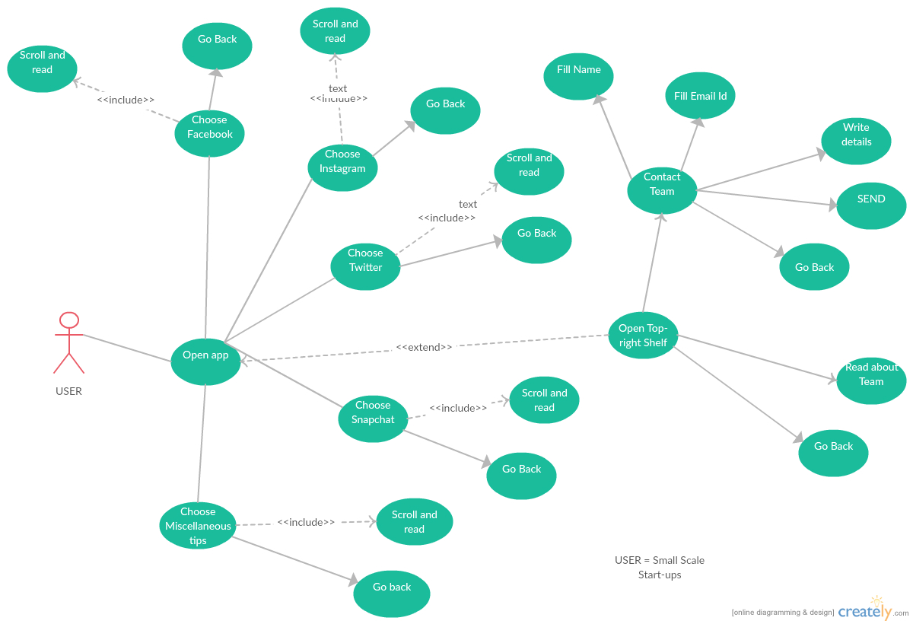

**2.5 Design and Implementation Constraints**

* Login and password is used for the identification of users.
* Only registered users will be authorized to use the services.
* This system is working for single server.

## User Documentation.

## Modern marketer provides access to an entire online marketing document can be used online for free if available or purchased according to terms and conditions stated as such, or through the help of online video tutorials which is readily available on YouTube or through their customized app and other social media sites can be used too.

## Assumptions and Dependencies

We assume that extra documentation beyond this SRS would not be necessary in order for the user to utilize this product.

# External Interface Requirements

## User Interfaces

The first interface is the startup screen when you open the application. This is where the user will have to create a specific Username and Password so that they can gain access to the available database and utilize it for the branding of their products. Next is the modules. You can choose on which platform you would like to use. This will be done manually by clicking specific activity buttons. The interface will be light and easy to handle so that multiple users can login at a time through their mobiles or tablets. Thus efficiency and light software build-up will be our priority.

## Hardware Interfaces

The app will we able to run on all android devices (phones and tablets) with Android 4.4(KitKat and up).

**3.3 Software Interfaces**

This app will require Android OS 4.4(KitKat) and Up to run properly and will have a license specification accordingly.

# System Features

The services provided by our app is as follows:

* Toggling between modules
* Ability to view the menu
* View all modules
* Scroll and read from modules
* View contact team team details
* View the details about company

**4.1 Main Menu/Navigation Bar**

This is the main navigation bar menu, from where the user can get to any feature in the app. This can be accessed anytime using the navigation bar button or by clicking the back button at any phase in the app activity cycle.

**4.2 Sub Modules ( Facebook, Instagram, Twitter, Snapchat etc.)**

These are the main data containing modules of the app containing the various information and instructions for the user to set up their social media platforms using ‘The Modern Marketeer’ app.

**4.3 Settings/Help/About**

This is the main side menu containing help instructions to guide the user as to how to set up each platform and to guide the user how to use the app effectively.

**5. Other Non-functional Requirements**

**5.1 Performance Requirements**

The app will require basic phone handling experience from the user and basic operations like clicking on a button, navigating with scrolling and switching through different modules using the back and swipe button activity features.

**5.2 Security Requirements**

The app will not require any additional security except the regular license and material security policies provided by the android app publishing app, Google Play.

**5.3 Business Rules**

The app will not contain any specific business rules to follow except anti-piracy of the application and legal use by the user.